Grade 7 Accelerated · Unit 3 · Lesson 3  Exponential Expressions  Question Bank - Additional 3.03 ANSWER KEY | Name  Date  Period

Show your work. Circle your final answer.
1. Two students evaluated 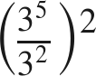. Rylan first wrote 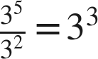, then 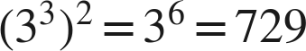. Liam first wrote 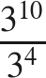, then 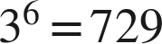.
a. Name the law Rylan used first, and the law he used second.
quotient of powers, then power of a power
b. Name the law Liam used first, and the law he used second.
power of a quotient (with power of a power on top and bottom), then quotient of powers
c. List the laws needed to evaluate 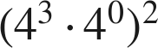, then evaluate it.
zero exponent (or product of powers), then power of a power; 

For questions 2 through 6, use the laws of exponents to evaluate. Show each law you use.
2. 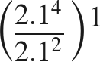
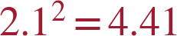

3. 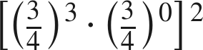
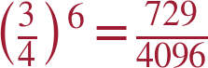
Math Nation's key prints 729/4,046 for this item; 4⁶ = 4,096.

4. 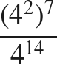
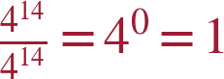

5. 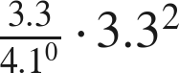

6. 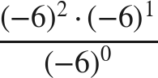
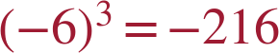

Equivalent or not.
7. Select ALL of the expressions that are equivalent to 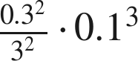.
☒ A. 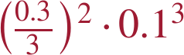
☐ B. 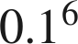
☐ C. 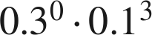
☒ D. 
☐ E. 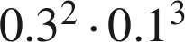
☒ F. 
A, D and F
0.1² · 0.1³ = 0.1⁵ = 0.00001.

8. Which expression is equivalent to 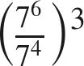 ?
● A. 
○ B. 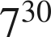
○ C. 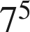
○ D. 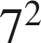
A

Working backwards.
9. Find the value of that makes each statement true.
a. 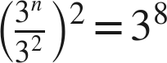
n = 6
b. 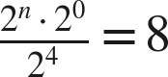
n = 7

10. Kim says that 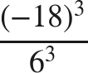 can be rewritten as 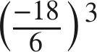 before evaluating. Is she right? Name the law, and give the value.
Yes — power of a quotient, read from right to left; 

